EXP. 1 : BREAD BOARD AND MULTIMETER

CIRCUIT DIAGRAM :

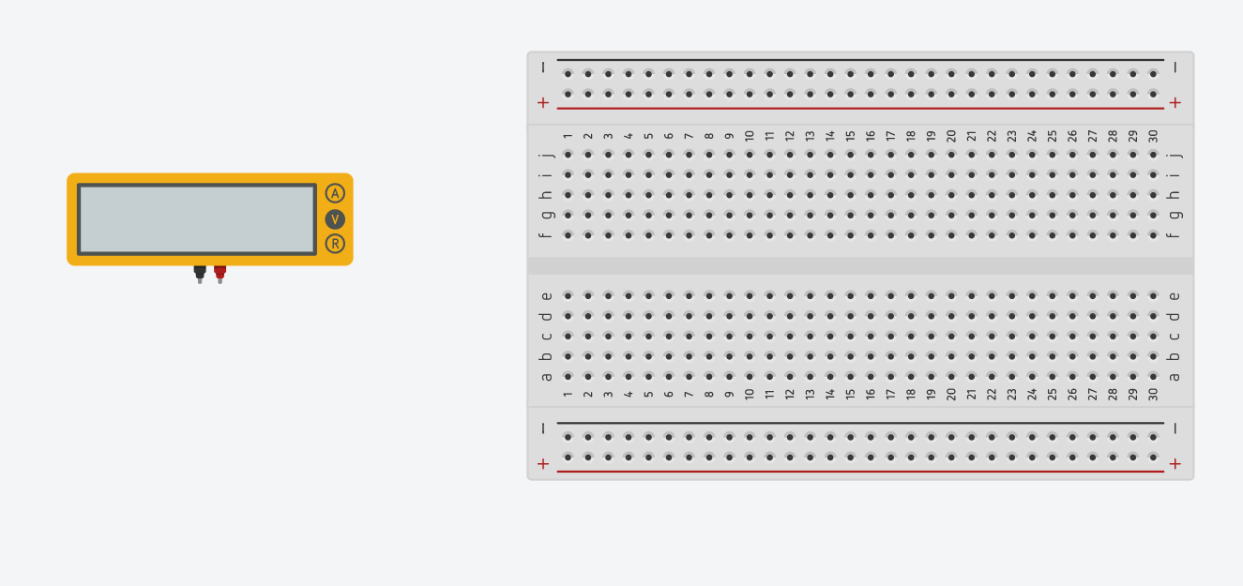

THEORY :

CONCEPT USED : In this experiment first we used the basics of electronics like connections on breadboard, connecting the led to the breadboard, and measuring the voltage of a resistor by a multimeter.

LEARNING AND OBSERVATIONS : Through this experiment I learnt about the connections in breadboard. We can understand the series and parallel flowing connections in the breadboard and we can use them for connecting accordingly. Multimeter is a device which is used to measure the voltage of a resistor.

PROBLEMS & TROUBLESHOOTING : While we use breadboard we have to be sure that it is either long or short breadboard. Because some parallel connections in long and short breadboard may differ.

PRECAUTIONS :

* We have to check whether the breadboard is long or short.
* In multimeter we have see that when checking voltage we have to start with the highest value in mutimeter.
* We have to Check the voltage of resistor from higher to lower values of multimeter until we get the accurate value.

LEARNING OUTCOMES : From this experiment we can learn the connections on breadboard and checking of the voltage of the resistor. By making connections on breadboard we can improve our creativity skills by making the connections in different ways. We can learn how to check the voltage of resistor by using the multimeter.